NHS Falcons News

Volume 1, Issue 2 November 2017

**This month for NHS in a snapshot:**

-Supply Drive

-Yard work Day

-Tutoring

**School Beautification**

On October 14th, the school beautification committee held a work day to clean up Jordan’s grounds. They targeted the enclosed courtyard in the school and did some work between the 300 and 400 wings. As stated in the last newsletter, one of the goals of the committee was to “restore the courtyard back to a great state for everyone to enjoy.” It is only November and they’re already checking things off of their list!

Community Tutoring

The community tutor committee has been active at Githens Middle School tutoring their students and helping them study.

**Publicity and Archives**

A new feature of the website we added this month is a “Photo Gallery,” where we will post additional pictures that we did not fit into the newsletter. If you are interested in seeing more pictures from the committees check it out. If you have pictures you want to be added from your committee please email them to Becca.

**In-House Tutoring**

NHS has been holding tutoring Tuesday mornings and Thursday afternoons. If you need help or know somebody that needs extra help or wants someone to study with, come on in! Tutoring is in Mr. Holthaus’ room.

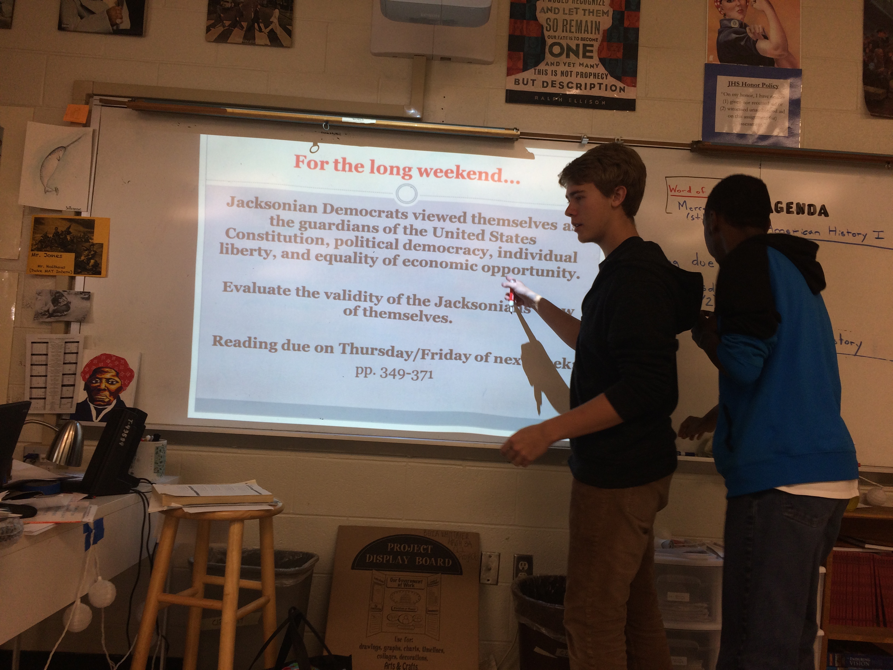

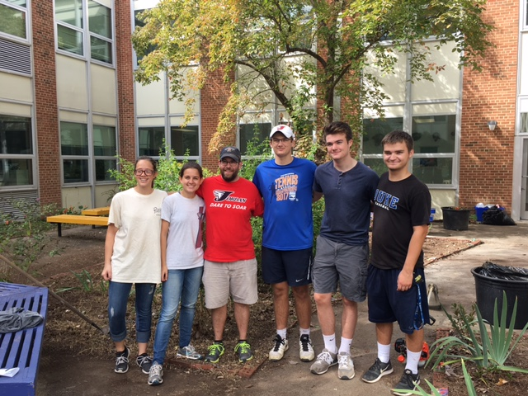

**Teacher Support**

This month the teacher support committee did a supply drive and handed out supplies to Jordan teachers. They are working to meet teacher’s needs and help them out.

Starting next month NHS will be recognizing students of the month. We will feature them in the newsletter as well as feature them on the “Student of the Month” tab on the website.

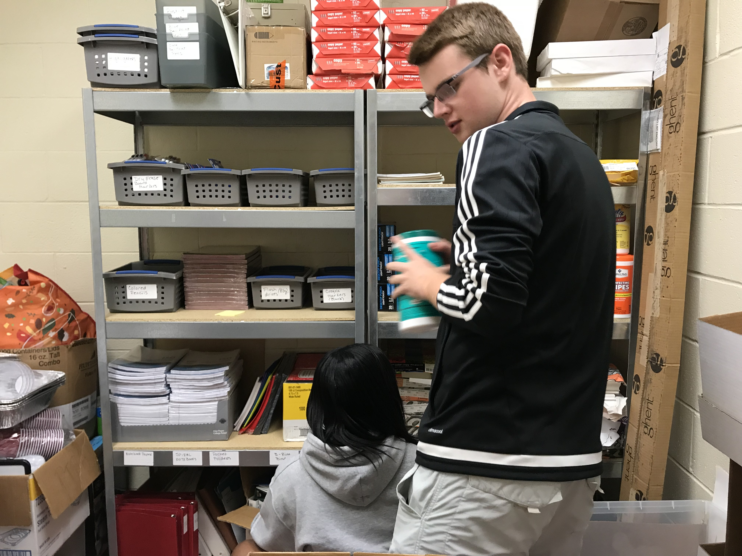

For more pictures and previous newsletter visit our website at jordannhs.weebly.com