NHS Falcons News

Volume 1, Issue 1 October 2017

Meet the 2017-2018 NHS Committees

NHS ADVISORS: Joseph Holthaus and Katherine Saveliff

**Community Tutoring**

"Our biggest goal for this year is to help our peers and younger children in the community acquire the knowledge and organizational skills they will need to improve their grades and prepare for their next steps in life. We have already begun to reach out to members of the community about tutoring and other educational opportunities.

In our first meeting, our committee noted that we feel it is important to continue tutoring the community for the entire duration of the school year. We have made it our goal to always be available for educational aid so that the goals of those we tutor will continue to be achieved."

-Committee Head: Madeline Yancy

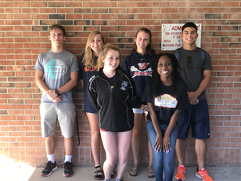

**School Beautification**

“The school beautification committee is working on improving the school. Currently our committee talked about trying to clean up and work on the courtyard in the basement square of the school, with the potential of raising money and repainting the benches. When permission has been granted to go through with these ideas, we will be restoring the courtyard back to a great state for everyone to enjoy.”

-Committee Head: Jackson Parrott

**Teacher Support**

“Our goal is to help out the teachers as much as possible and to get them their supplies needed efficiently and fast. We want to help them out with a supply drive, and however else we can.”

-Committee Head: Bella Lima

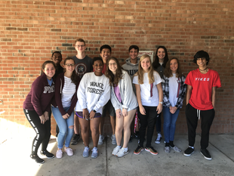

***What is NHS?***

Founded in 1921, the National Honor Society has been an organization dedicated to recognizing outstanding students and providing an outlet for them to serve their communities. The students within the organization represent the four pillars of NHS: scholarship, leadership, service, and character. Throughout the year, the Jordan High School chapter will be dedicated to serving both the school and the Durham community through tutoring, service projects, teacher outreach, and school beautification. Stay tuned for more updates throughout the year on what our scholars are achieving!

CHECK OUT OUR WEBSITE THROUGHOUT THE YEAR FOR PICTURES AND UPDATES:

[www.jordannhs.weebly.com](http://www.jordannhs.weebly.com)

**Publicity and Archives**

“Ultimately, our goal and role for this school year is to keep our peers aware of what NHS is doing in our Jordan community. Through updating and maintaining a website in a timely fashion, ([www.jordannhs.weebly.com](http://www.jordannhs.weebly.com)) , we hope to help students take advantage of tutoring and recognize what NHS is doing and how they are and can benefit from it. We hope to document this chapter of Jordan High School NHS through many pictures and newsletters.”

-Committee Head: Becca Whittaker

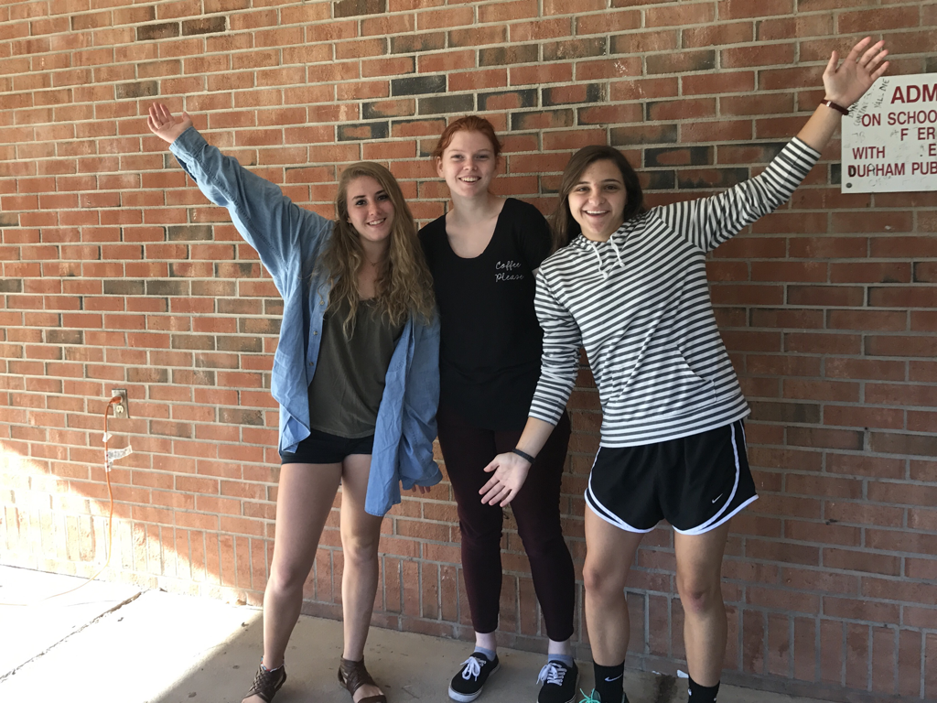

**In-House Tutoring**

"This committee's long-term and short-term goals for the year are quite simple: we want to help students with their studies and help them learn something they didn’t know before. Currently, we’re working towards this goal by getting the word out to people. We haven’t had many students come in thus far, and we need to drive in more traffic. We will be spreading the word about our availability by posting flyers around the school building with times and places to meet with members of our committee should students need help with their studies."

-Committee Head: Justin Gunn

Need Help In Math, English, History, Spanish, French, Science, etc.? Check out our FREE tutoring by NHS members in Room 414 on Tuesday’s and Thursday’s.

